The Mass Trespass on Kinder Scout, the Communist Party
and the British Workers’ Sports Federation in the 1930s.
A few questions to start with. Reflect for a few moments on your knowledge and awareness of the 1932 Mass Trespass on Kinder Scout.
Who organised it?
Where did they come from?
What were they aiming to achieve?
What did it mean to them?
How did they relate to other groups and organisations campaigning in the 1930s for recreational access to the countryside and/or rights of way?
Why didn’t they do it again?
And, more generally, how does your awareness of the 1932 Mass Trespass inform your own activism / campaigning, in urban as well as rural environments / landscapes?

In his 1988 book on sport, politics and the working class in the 1920s and 1930s, the historian Stephen Jones observed that: ". . . the [mass] trespass is a particularly good instance of class conflict in the recreational sphere, and perhaps the most famous single incident in the history of the movement for access to the countryside."
Almost 100 years after the Mass Trespass, it has indeed achieved a much-celebrated place in the broadly-defined access movement’s self-histories. It has become an inspirational myth of heroic endeavour, memorialised in the oft-sung Manchester Rambler. Contemporary outdoor access groups make their ritual obeisance to the men and women who set off from the Bowden Bridge Quarry in Hayfield on Sunday, 24 April 1932 to walk up to the commanding moorland heights of the Kinder Scout plateau.
What has been air-brushed out of the myth are the political and organisational realities of the event itself and its grounding in the politics of the Communist Party of Great Britain [CPGB] and the Young Communist League [YCL] in the early-1930s. What has been forgotten is the fact that the most vociferous criticism of the Trespass came, not from rentier landowners and their tenant proprietors and gamekeepers, but from just about every other countryside organisation and group campaigning in the 1930s for public, recreational access to outdoor landscapes.
This Trespass Resource is not a full account of the events of 1932 and its subsequent history and resonance; you can find out about these more fully elsewhere. What we offer here is a more focussed reflection on the political contexts and influences which gave rise to the Trespass, what it meant to those organising and taking part and its relationship to those other organisations campaigning for access and rights of way
______________
Trespassing on Derbyshire Moorlands
Trespassing on the Derbyshire moorlands of Kinder Scout, Bleaklow and Black Hill was not invented by the 1932 Mass Trespass. Trespassing had been an integral part of Peak District walking and climbing since the late-19th century. Pioneering gritstone rock climbers such as James Puttrell from Sheffield and Siegfried Herford and Ivor Berg from Manchester may have sought permission to climb on the crags surrounding Kinder Scout (Downfall area, Northern Edge), Bleaklow (Shining Clough) and Black Hill (Laddow). But they also simply turned up and climbed where and when the fancy took them.
For those who created and regularly repeated the classic long-distance bog-trotting walks across High Peak moorlands – Edale-Marsden; Derwent-Watershed; Four-Inns – trespassing and evading the gamekeepers who policed the exclusion from the moors on behalf of the owners and grouse-shooters was a routine part of their walking lives. A section on how to trespass and deal with gamekeepers was included in the Peak District and Northern Counties Footpath Preservation Society’s 1911 handbook on Ramblers and the Law. Such leading figures of Peak District rambling and access campaigns as G H (Bert) B Ward – the founder of the Sheffield Clarion Ramblers in 1900 – and Phil Barnes, a prominent member of the Peak District branch of the Council for the Preservation of Rural England (CPRE) in the 1930s – were celebrated trespassers. Phil Barnes even published a 1934 book of photographs and accounts of trespassing ramblers: Trespassers will be Prosecuted.
So by 1932, trespassing on Kinder Scout was not a novel idea. It was part and parcel of moorland walking – especially for ramblers from Sheffield who could easily walk across low-lying countryside within the city’s eastern boundaries and continue directly on to the forbidden peat-capped moorlands.
Walking and Political Protest
Moorlands weren’t the only places where people walked in the 1930s. By the 1920s and 1930s there were well established traditions and routine practices of radical / progressive / protest walking to demonstrate / build solidarity and exert pressure to achieve political, social and economic ends:
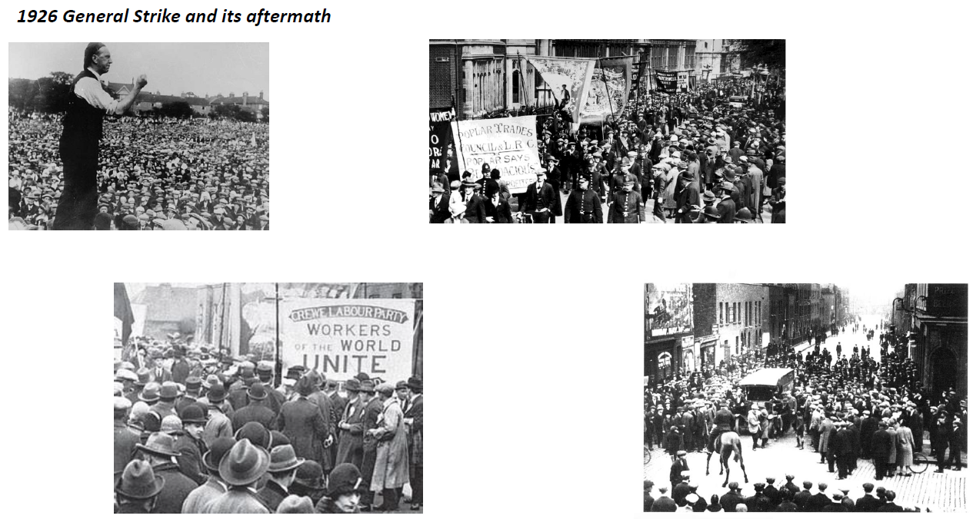

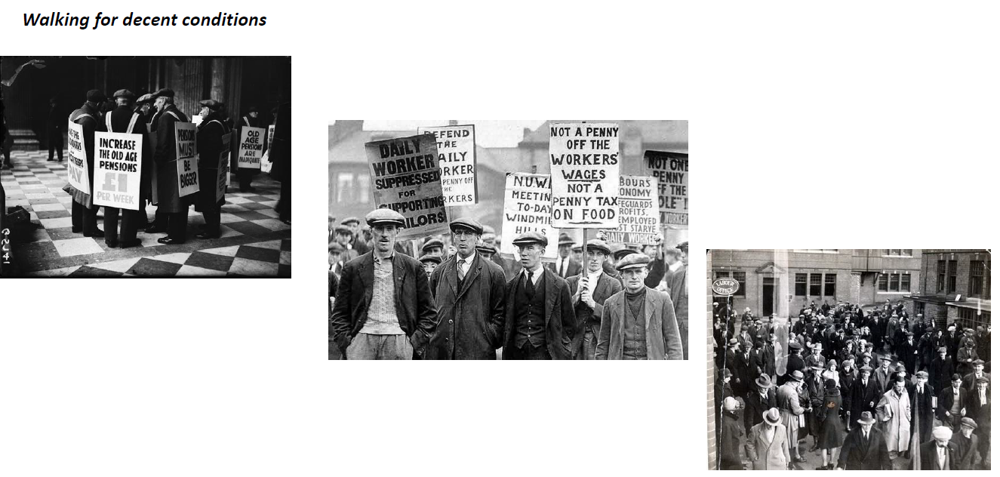
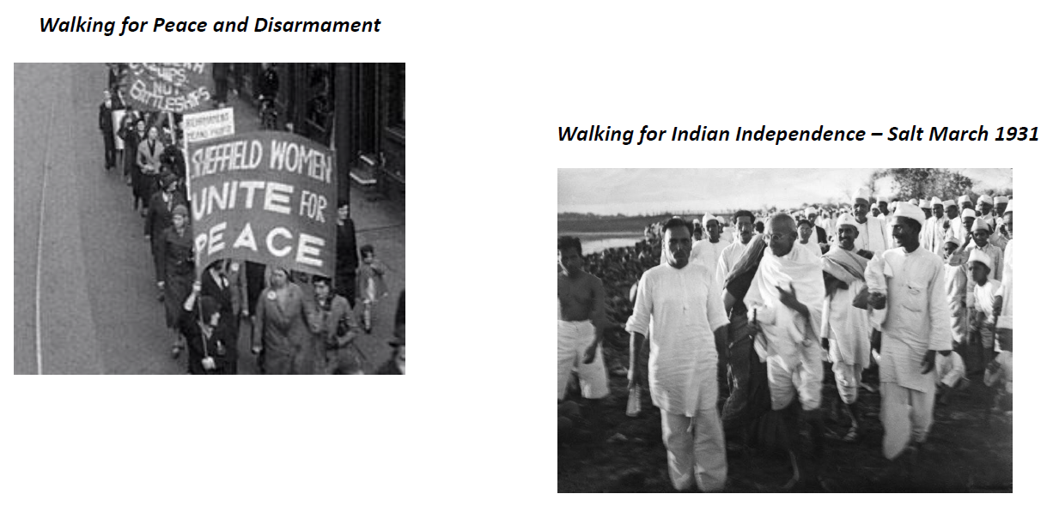

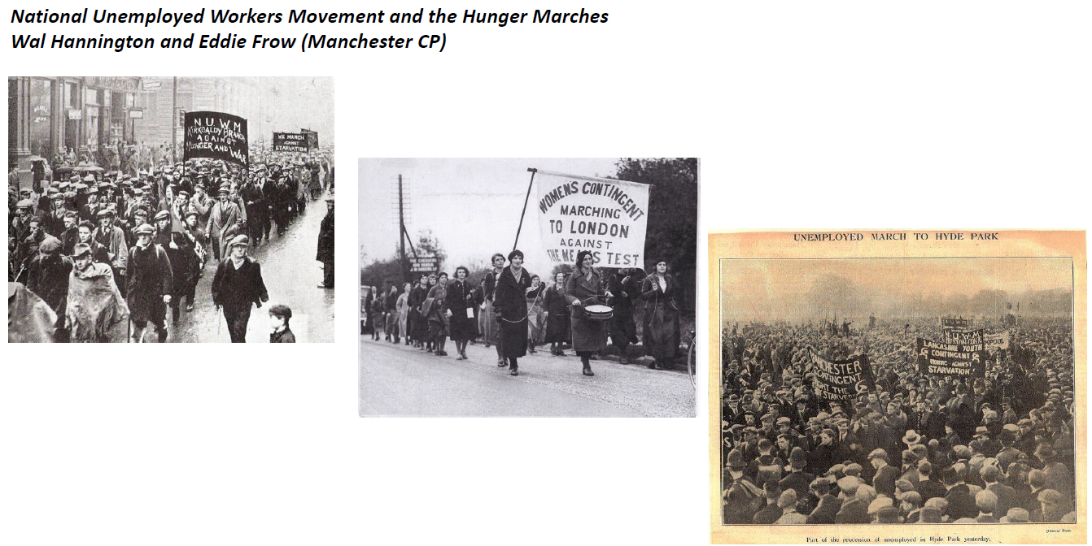

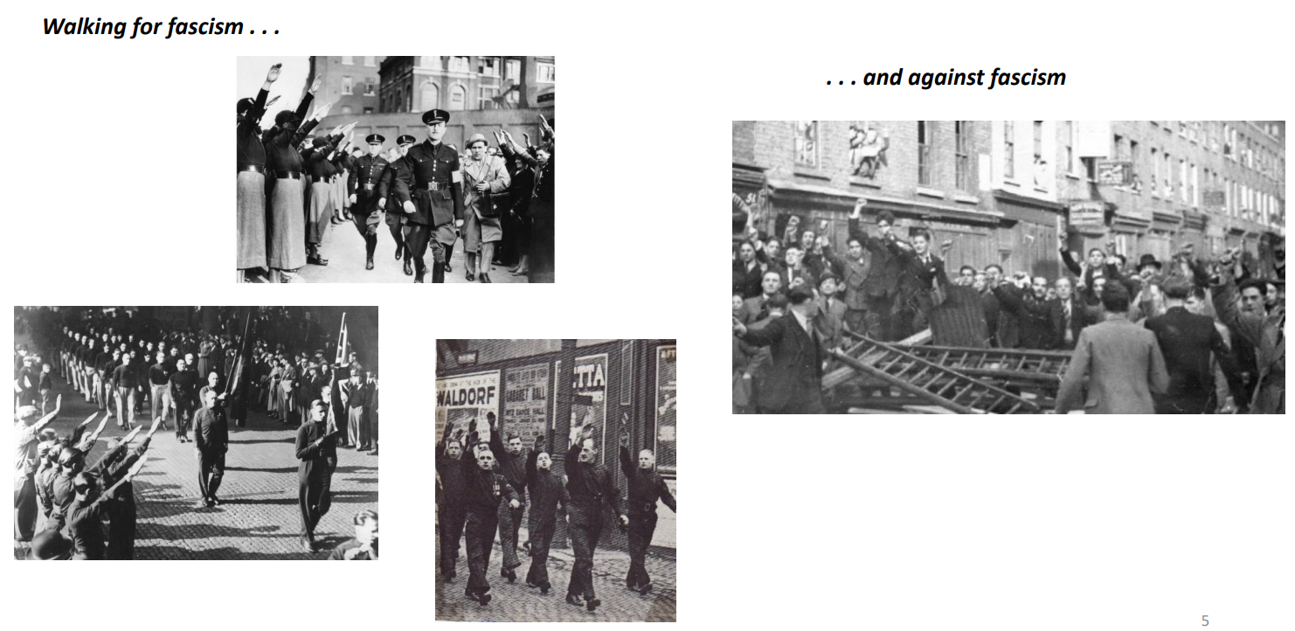

Occupying streets and public places through walking collectively had become a routine dimension of political activism by the 1930s – heightenend by the circumstances of the inter-war global Great Depression and the failure in the UK of the Labour and National governments at the time to do anything to address people’s increasing poverty and sense of injustice. This was mass urban walking, not to the sound of grouse or wind blowing over peat and heather but against the background sounds of factories, poverty and songs of solidarity.
Perhaps this is the music which might accompany such walking: https://www.youtube.com/watch?v=cDbatoAvuB4

Demonstrations and ‘street politics’ shaped the landscapes in which, in the late-1920s and early-1930s, the working class, urban youngsters who joined the Lancashire branch of the British Workers’ Sports Federation came of age and formed their political outlooks and commitments.

Think for a moment or two about your own experience of walking in urban and rural landscapes.

Do you identify yourself as primarily urban? If so, how do your urban walking identities relate to your rural walking identities?

Do you seek to escape from urban environments into ‘natural’ environments?

How do those identities shape your own political outlooks?
Where do you walk collectively? Where do you prefer to walk individually or with a small group?

Do ‘demos’ and ‘rambling’ occupy different dimensions of your identity as a leisure-time walker / climber / swimmer / mountain-biker / hang-glider . . . ?

The British Workers’ Sports Federation
The British Workers’ Sports Federation (BWSF) was set up in 1923 by the Labour Party [LP] and the TUC, with the support of the Clarion Cycling Club. Its aim was to create opportunities for the working class to engage in the full array of sporting activities; not just masculine football, but athletics, the entire range of Olympic sports, tennis and so forth. It had a strong international orientation – Footballs not Canonballs; Peace through Sport.
At the same time, the YCL, the youth section of the CPGB, was actively exploring the opportunities for British working class sportsmen and sportswomen to participate in the Red Sports International [RSI] set up in 1921 in the wake of the Russian Revolution. Rather than pursuing the BWSF’s leisurely, Clarion approaches to socialism, the YCL and RSI were enthused by the idea that ‘physical culture, gymnastics, games and sport are a means of proletarian class struggle. . . accessible to all proletarian elements which recognise the class war.’ The conflation of physical / sporting activity and class struggle entailed developing a critique of all aspects of sport which were likely to undermine the class struggle and/or provide support for the ruling class. So, for instance, the YCL opposed scouting, sports clubs run by factory owners and commercial sports generally. By 1928, the likelihood was that the YCL would set up its own sports organisation and, in this way, the BWSF and the YCL’s mooted new organisation would have reflected the established political divisions between Labour Party reformists and CPGB revolutionaries.
In the event, these political differences played themselves out within the BWSF at its 1928 National Congress. In the elections for officers and the committee, members of the YCL gained a majority and took effective control of the BWSF. Changes were made to its aims and objectives; from 1928, the over-arching objective of the BWSF was to support sportsmen and sportswomen in: “an unrelenting struggle against the existing capitalist domination of sport, and the introduction of a socialistic content into sport and physical recreation.”
Not surpringly, the General Council of the TUC felt obliged to withdraw its support from the BWSF; the National Executive Committee of Labour Party made a similar move and the Clarion Cycling Club severed its connections, complaining of the links with the RSI. Although membership of the BWSF remained open to workers from any party and none, the CPGB, through its youth wing, effectively organised the activities of the BWSF.
_____________
To appreciate the significance of the CP / YCL control of the BWSF, we have to take account of the political strategy – or ‘line’ – adopted by the CPGB in the late-1920s. After their emergence as distinct socialist parties in 1918, the CPGB and the LP had maintained a rough-and-ready ‘united front’ as partners in the business of creating a working-class based socialism across the post-WW1 UK. By the time of the 1926 General Strike, however, the growing divergence between their political styles and tactics had become apparent. The divergence was formalised in 1928 when the CPGB adopted a new overall political strategy / line usually referred to as Class Against Class (CAC).
The CAC line meant that the ‘united front’ approach was ended. The CPGB’s new strategic line was to confront / oppose the leaderships of the Labour Party and the trade unions on the grounds that they were effectively colluding with capital / capitalists against the interests of the working class. This was not just bolshevik sectarianism or crude workerism. It had a resonance in people’s lived experience at a time when many of the reforming socialist parties across Europe were adopting free market and austerity-based policies in response the Great Depression. The policies of Ramsay MacDonald’s 1929 – 31 Labour government and the National Government he led after the 1931 election was a stark demonstration of that tendency.
There was a clarity about CAC. It incentivised the CPGB to make a range of dramatic political interventions in the early-1930s, not just in terms of politics and economics, but more widely in terms of cultural initiatives which offered working people newer perspectives and opportunities. The BWSF was one such cultural initiative; its opposition to “bosses’ sports” and the increasing commercialisation of sporting activities generally may strike us as a tad shrill; but it chimed with people’s experience of leisure-time as a form of potential social control. If ‘religion had been the opium of the masses’ for Karl Marx in the 19th century, commercial, consumer-based leisure-time opportunities had the capacity to serve a not dissimilar ideological function in the 1930s.
The BWSF was not the only CPGB-led organisation in the cultural / leisure-time sphere. The Workers’ Theatre Movement [WTM] was providing alternatives to commercial entertainments. It gave a voice to working-class and radical actors, access to plays and drama, and dramatic representations of working class lives and struggles along the lines of, say, Brecht in Germany – as well as laying the foundations for a general widening of the scope of the performing arts generally. The CPGB sponsored bookshops and cafes and, through the Daily Worker, provided a different set of perspectives, not just on labour movement matters but all other dimensions of the news.
The CAC years were ones of vibrancy and excitement for members of the CPGB. To be a CP or YCL member at that time was to lead an all-consuming political life-style alongside one’s comrades and friends. It generated an optimistic activism to usher in newer and more radical sets of personal and social values and behaviours.

The Lancashire Branch of the BWSF and the Mass Trespass
In the early-1930s, the young, unemployed Benny Rothman (b.1911) was a member of the YCL and the energetic secretary of the Lancashire Branch of the BWSF. He had gained a sense of ‘outdoor socialism’ from the Clarion Cycling Club; he had found his way to the Peak District for camping and outdoor activities. His life-long friend and CP comrade, Eddie Frow, was working alongside Wal Hannington (one of the founding members of the CPGB) in organising the hunger marches and other demonstrations of the CP-originated National Unemployed Workers Movement. Benny Rothman became actively engaged in the urban street politics which reflected the CP’s strategic commitment to enabling the working class to advance the cause of socialism through its own direct efforts. True to the BWSF’s new aims and objectives, they were also extending the class struggle into their outdoor sports.
In one of their Peak District summer camps in 1931, members of the Lancashire BWSF were strong-armed off the private moorland of Bleaklow by an aggressive group of gamekeepers. Not surprisingly the BWSF comrades felt they wanted to get their own back on this assault by the lackeys of the ruling class – and thus was born the notion of a Mass Trespass.
For the BWSF, this was not a matter of joining or working alongside such groups and organisations already engaged in securing rights of way and countryside access as:
- Manchester Ramblers Federation (established in 1922)
- Peak District and Northern Counties Footpath Preservation Society (established in 1894)
- The Commons, Open Spaces and Footpath Preservation Society (established as the Commons Preservation Society in 1861 by the liberal philosopher and sometime MP, John Stuart Mill)
- The National Trust (established in 1896 to enable the working classes to appreciate the beauty of England’s natural heritage)
- The Council for the Preservation of Rural England (established in 1926 to prevent what it saw as the destruction of rural landscapes)
- Those Liberal and Labour MPs who had every few years sought to introduce the ‘Access to Mountains (Scotland) Bill’ This was first introduced in 1888 by the polymath politician and mountaineer Sir James Bryce. Based on the access customs in Scotland, passing the Bill into law was seen as the main focus for access by most of the outdoor recreation groups listed here. After 1921, the Bill

was introduced every few years by a Labour MP. It was never successful until 1939, when the upshot was a complete disaster – it made trespass illegal – and it was dropped after the second world war when the National Parks were established in 1949.
For the YCL-led BWSF in the era of CAC, making common cause with such august and respectable countryside bodies was not on their political agenda. In their various negotiating and lobbying activities, those bodies all tended to cosy up a bit too closely to the landowners and the ruling class. They tended not to welcome young people into the countryside; they were still largely Victorian in their moral outlook; they opposed the growth of ‘camping’ and the use of the American term ‘hiking’ to refer to the noble arts of walking, rambling and moorland bog-trotting; they lectured working-class ramblers on how they should behave in the countryside; they did not comprehend or accept the first stirrings of mass – i.e. working-class – leisure-time which was taking young people from urban environments into the countryside. . . This rejection, on their part, of wider social access was summed up in the words of the CPRE Kinder trespasser, Phil Barnes, mentioned earlier:
I am afraid I care for Kinder so much that I am perhaps taking a rather selfish view but, frankly, I would rather stay away from the hills myself and leave them to the tender mercies of the shooter and the keeper, than see the delicate beauty of these cloughs vulgarised by picnic parties, as for instance the Conksbury Bridge end of Lathkill, or the Thorpe end of the Dove are today.
The YCL / BWSF comrades were opposed to any sort of collaboration with organisations which did not have the interests of the working class at their heart. It was up to the working class to decide for themselves how to end their exclusion from the High Peak moorlands through their own direct agency and actions.
Fifteen years earlier the Bolshevik comrades had shown how to set about the task of advancing the cause of socialism in the face of exclusion from the moorlands. The BWSF should storm their own Winter Palace and seize the commanding heights of the Derbyshire moorland economy; they should extend the reach of their customary, collective urban protest marching and undertake a Mass Trespass on Kinder Scout. This is what insurrectionary communists / workers / hikers should do in the circumstances in which they found themselves in 1931 and 1932 . . . .
And, with panache, good organisation, and a remarkably astute sense of how to choreograph such a dramatic moment in the class struggle, that is what they did on Sunday 24 April 1932.

_______________

Here is a copy of one of the publicity leaflets produced by the BWSF and distributed, in this instance, to the “young workers of Eccles . . . ”
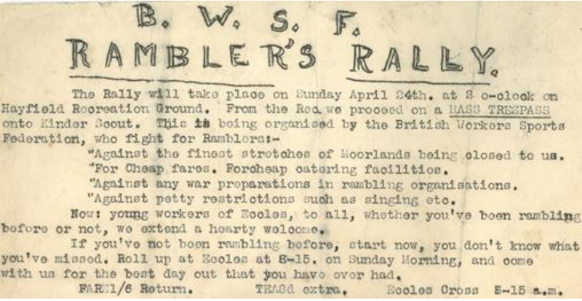

We’ll say a bit more about this shortly. But it is worth pausing now and reflecting on your initial reactions to the BWSF and its CP / class struggle approach to rambling and outdoor activities generally.
Did they make the right decisions?
Were they ‘too political’ in their approach to leisure-time activities for young workers?

Would the promise of ‘the best day out that you have ever had’ have persuaded you to go to Hayfield?

If you opted not to go to Hayfield on 24 April 1932, this is who did . . .

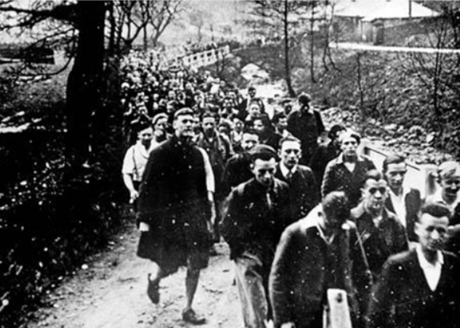

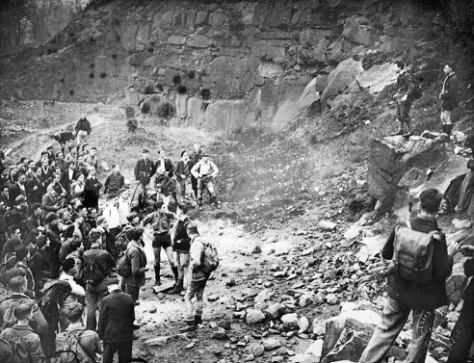

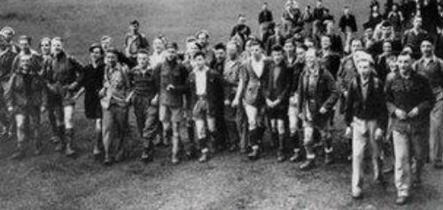

The BWSF’s Four Access Demands
It is worth noting that three of the four demands made by the BWSF were not made by any of the other organisations / campaigns calling for recreational access to the countryside.
The first demand was simply an assertion that they were “Against the finest stretches of moorland being closed to us.” What they didn’t explicitly demand – because it was taken for granted – was ‘taking the finest stretches of moorland into common / public / state ownership’. They had read the Communist Manifesto, where it clearly stated that: "The theory of the Communists may be summed up in the single sentence: Abolition of private property". This was reinforced by the Manifesto’s proposal that one of the the first tasks of a socialist government would be the Abolition of property in land and the application of all rents of land to public purposes. This was way beyond the nationalisation options hinted at in a reformist Labour Party’s 1931 Election Manifesto. The BWSF located themselves squarely in that tradition of the common ownership of land initiated by The Diggers’ Trespass of 1649 during the English Revolution.
The remaining three demands put the 1932 trespassers at odds with the main groups seeking recreational countryside access. Cheap transport was a fundamental necessity to enable an urban working class to enjoy a good day out on the moorlands. As were facilities for cheap food and drink. Such simple material demands were out of line with the concerns of the rural preservationists of the 1930s. The pervasive preservationist strand of the outdoor movement opposed many of the signs of ‘rural modernism’. They opposed the growth of rural cafes catering for visitors. They sought to constrain / reverse the growth of tourists, cars, widening roads, petrol stations, holiday-makers in rural landscapes. They opposed the growth of suburbs destroying the green belt countryside around the major conurbations. Easy, ready access was not on the rural preservationists agenda and, in many instances, preserving the countryside meant restrictions on and/or greater policing / control of recreational access.
The issue of ‘war preparations’ is interesting. The BWSF opposed scouting, military marching etc and were at that time supportive of the inter-war peace movement. But it is hard to identify specific rambling groups which were explicitly engaged in ‘war preparations’. This demand may have been a way of opposing the increasingly strong ideological / cultural tendency for rural landscapes to become ‘storied grounds’ expressing an essentially English / British / Imperial identity.
The fourth demand to oppose ‘petty restrictions such as singing etc’ is aimed directly at the leaders of the main outdoors and rambling groups, who sought to impose strict and respectable codes of behaviour on the younger generation of hikers, campers etc. The Mass Trespass was part of a more widespread generational shift in the outdoor recreational world – and this gave rise to well-documented differences over what constituted proper behaviour in the countryside. In 1931, the President of the Manchester Ramblers Federation, Edwin Royce, noted:
When the craze for excitement, which afflicted us during the immediate post-war days, had spent itself, the countryside came into its own. Tramping suddenly rose to the heights of popularity, till now it is a fashion – being able to throw a rucksack over one’s shoulder and proclaim to the world ‘I am a hiker’…[M]any members of clubs are members because of the social life, and not because of the tramping…Instead of discussing the sculpture of the earth and the fullness of life and beauty which is upon it, many club members are engrossed with the latest dance or talkie.
. . .[the] superficial person who takes up rambling because it enables him or her to indulge in a childish taste for fancy dress or who looks on the countryside as merely a place for skylarking. When they have put away childish things we shall be pleased to see them…helping with the serious side of rambling on the Federation Council.
The BWSF’s promise that the Rambler’s [sic!] Rally in Hayfield would be “the best day out you have ever had” also highlights the generational and class gap between the working class and the leaders of the official outdoor movement. Although holidays in seaside resorts had become popular leisure-time activities by the 1930s, the bulk of working class families still could not afford a full week away from home. For them, leisure-time highlights were ‘days out’; the BWSF spoke directly to and for that experience. Going for a hike in Derbyshire was also leisure-time fun and enjoyable; it was not some sort of solemn duty.

Hiking and Singing
Benny Rothman and his BWSF comrades were proudly urban. They enjoyed the latest films and dances and were comfortable in the city. They loved hiking across the moorlands, but they did not go there to escape from urban life into a better place. They went there to extend the sphere of freedom in their lives. One of the youngest trespassers was a lad called Jimmy Miller – who later renamed himself and became famous as the folksinger Euan MacColl. He wrote The Manchester Rambler, which is often taken to be the anthem of the MassTrespass. Its well-known chorus includes the lines:
I may be a wage slave on Monday,
But I am a free man [sic] on Sunday.
For the BWSF and the trespassers – men and women – walking in the hills pre-figured the freedoms the CPGB and YCL were fighting for in their urban lives. Being there was not ‘time-off’ from the politics of the class struggle – it was a continuation of the class struggle into a rural landscape from which they were excluded.
And they did, indeed, sing whilst they trespassed. As it happens they did not sing the Manchester Rambler; that came later. Having done their trespassing, they returned en masse down William Clough to Hayfield, singing The Red Flag, The Internationale and a song they had made up specially for the occasion, to the tune of the Road to the Isles:
We are young workers, who in search of healthy sport
Leave Manchester each weekend for a hike
Though the moorlands in Derbyshire are closed to us,
We ramble anywhere we [ruddy] like.
For by Kinder and by Bleaklow and all through the Goyt we'll go
We'll ramble over mountain, moor and fen.
And we'll fight against the trespass laws for every rambler's rights
And trespass over Kinder Scout again.

In case you can't remember the tune and the rhythms, here's a copy.
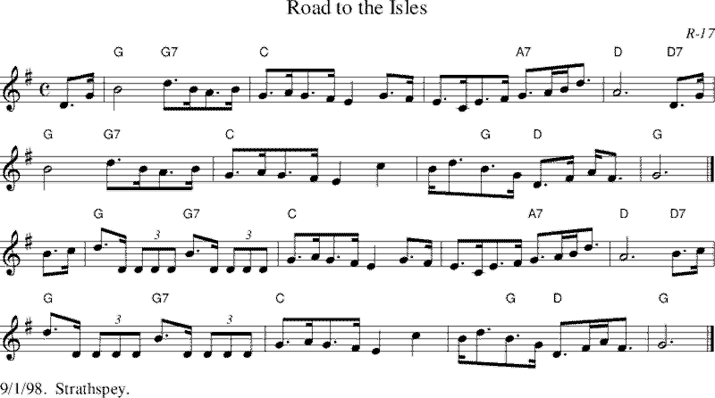

“Young” “Workers” “Sport” “Hike” These were not words heard, let alone sung, amongst the 1930s outdoor access organisations. They were sung by a group of trespassers at an event organised by the Lancashire Branch of the British Workers Sports Federation and the YCL as part of their contribution to the class struggle in 1932.
. . . And one of these days, one of the frequent celebrations of the Mass Trespass might get round to singing this particular song!

__________________

This Trespass Resource has not explored what happened when the trespassers returned to Hayfield to be met by a huge police presence – all police leave had been cancelled by the Derbyshire Police Force for 24th April 1932. The arrests, trials and imprisonment of five of the trespassers – along with a sixth man who was simply walking up William’s Clough and had played no part in the trespass! – gave the event massive national publicity and more widespread popular support than they may have expected.

Nor will we explore here the subsequent complex and often contradictory histories, myths and meanings of the Mass Trespass over the last 97 years. These are things for which there many other resources you can draw on.

Before drawing out some core questions and reflections on the politics of the Mass Trespass in 1932, we offer a codicil on one of the oft-raised questions . . .

Why didn’t they do it again?
The subsequent arrests, trials and imprisonment of Benny Rothman and others generated considerable national publicity and debate. Benny Rothman was guided by the CPGB throughout; on their advice, he opted to defend himself which gave him the platform to make political statements arising from the trespass itself and the overall conduct of the legal processes.
The simple fact remains, however, that regular moorland trespassing was fairly low down on the CPGB’s list priorities for political / class struggle activism. More immediately, there were NUWM hunger marches to be supported. The rise of fascism in the UK in the shape of the Mosleyite British Union of Fascists meant that there was an upsurge of street politics to oppose their marches in Manchester and Salford, not least in Cheetham Hill for the Jewish community into which Benny Rothman was born. More generally, there was an international mobilisation of CP members to fight against fascism in Spain. Several of the trespassers joined the International Brigades and a few lost their lives fighting there. Worth noting, that in the political complexity of the Spanish Civil War, the CPGB shifted its political line from CAC to the more internationally held ‘popular frontism’ from the later 1930s.
In the event, Benny Rothman did not go to Spain. He – and The Party – opted to exercise his organisational and political skills in the trade union movement. From the mid-1930s until he retired in the late-1970s, this life-long, disciplined member of the CPGB was at the heart of the trade union movement in Manchester and Salford as an AUEW organiser, shop steward and convenor. It has been argued that Benny Rothman did more to advance the cause of the working class in that routine, collective work than he did in a day of high drama on Kinder Scout. He did retain his love of hiking and moorlands: he continued to take parties of friends and comrades out into Peak District until he was confined to a wheelchair by a stroke in 1992.
__________
There was, however, another moorland Mass Trespass in 1932 on the eastern side of the Peak District. Sheffield walkers always had a sense that the moors of the High Peak were more properly their patch than Manchester's. Not wishing to be outshone by a bunch of Manchester insurgents / upstarts, there quickly arose a movement for a Sheffield-originated Mass Trespass. There was no branch of the BWSF in Sheffield and calls came from some of the more radical groups affiliated to the Sheffield Federation of Rambling Clubs.The proposal for a Sheffield Mass Trespass was put at a Federation meeting chaired by no less a figure than Bert Ward. As the doyen of access, tramping trespasses and the founder of the Sheffield Clarion Ramblers, Ward opted neither to oppose nor support the proposal. Indeed, he remained resolutely silent for the rest of his life on the subject of the BWSF's Kinder Scout Mass Trespass. Cannily, Ward suggested that those members of the Federation who wished to take the proposal forward should meet separately. Which they duly did – and were then advised by Ward on rights of way and the law of trespass in relation to the particular area of moorland where they proposed to do their trespassing.
On 18 September 1932, as the Kinder Trespassers were coming to the end their jail sentences, a second Mass Trespass of some 200 ramblers took place at Abbey Brook on Derwent Edge moorland. It was organised by, inter alia, the Woodcraft Folk, the Brightside ILP, Spartacus (the Sheffield branch of the YCL), the ILP Guild of Youth, Sheffield Education Settlement and the Clarion Co-operative Ramblers. The trespass involved a walk along a right of way which had been blocked, with the option of an extension on an open moorland trespass along the lines of the Kinder Trespass. They were met by at least 100 gamekeepers and a handful of police officers from the Yorkshire Constabulary, as Abbey Hey was just over the border from Derbyshre. After the right of way section there was a threat of quite serious violence from the keepers and, after sitting down, eating their lunch and discussing the situation, many trespassers turned back. A few others continued on to the 'trespass land'. The keepers urged the police to arrest them immediately and were intensely annoyed that the police had obviously been given very different instructions from those given in Hayfield on 24 April. They assiduously 'kept the peace', escorted the trespassers back to an agreed right of way and bade them farewell. There was to be no legal 'second act' to the Abbey Brook Trespass.
____________
The last bit of this codicil is to note what Benedict Anderson has dubbed The ‘Respectable’ Reaction on the part of the Manchester Ramblers’ Federation after the trespass.
The actions of the ‘hikers’ and mass-trespassers needed to be distanced from the MRF, and brought under control – and from around 1933, the MRF did indeed manage a set of ‘warden-guides’ in the Peak who were supposed to manage and watch the behavior of walkers over the moors.
These attempts to regulate countryside behaviour by the the Manchester Ramblers’ Federation and other organisations such as the Council for the Preservation of Rural England (CPRE), represent the beginnings of the regulated forms of countryside conduct that are familiar to us today. Numerous ‘volunteer warden’ schemes were set up in the early 1930s – including, apparently, 8000 recruits in Derbyshire – the first attempts were made (by the CPRE – the Manchester Ramblers’ Federation actually refused to take part) to create a ‘Code of Courtesy for the Countryside’ between 1933 and 1935, and all this from the same groups who were most closely involved in advocating for the Peak District as the first national park. While the Kinder Scout mass-trespass presaged a period of genuine progress on the issues of access to the outdoors, it also served to encourage existing rambling organisations to think more about regulating conduct than promoting freedom, and to establish some of the closely-defined behaviors that characterize so much of outdoors leisure today.

___________________
_____________
_____

We hope you have enjoyed this history-based resource and learned something of interest and value to your own trespassing endeavours.
We have not presented this political history of the 1932 Mass Trespass as a model or template to be adopted by those organising many different forms of trespass and trespass-style activism a hundred years later. The Mass Trespass of 1932 was deeply shaped by the Marxist politics of the CPGB at that time. But that does not mean that all subsequent trespass activities should have a similar underlying political orientation.
The political legacy of the Mass Trespass for trespssers in the 2020s is actually much more complex and more challenging. The following observations point to a couple of broadly defined political issues which you and your co-trespassers will have to negotiate when locating your trespass within the turbulence, complexity and conflicts of the wider political environment(s) of the 2020s,

- Land Justice: the political economy and ideology of property and ownership

Whether you are occupying a small patch of land, a short stretch of riverbank, the entire length of the river, a privatised area of once public urban space or an area of a building, your actions will be making a political challenge to the existing political economy and ideology of property and ownership. Your prime concerns may well be more social and cultural; you may well be driven by a deep sense that you belong and/or ought to belong in that particular space. Bear in mind, however, the words of the late Doreen Massey, a geographer of space and place:
“Feeling you belong to a place in no way entails that it belongs to you. . . Ask not 'do you belong to this landscape?' but 'does this landscape belong to you?”

In the 1930s, there was a relatively limited range of ways in which you could locate your political challenge. Nowadays you are faced with a plethora of political options in which to locate and underpin your trespass activism: umpteen different versions of Marxism and social democracy; a revived anarchism; a liberal commoning movement etc. . . through all of which you need to thread ways of linking your immediate actions with the imperatives of rectifying the historic local and global land and ecological inequalities and injustices. . . .

- Being politically canny: the risks and dilemmas of political fragmentation

An emerging characteristic of the political environments of the 2020s is the disintegration of classic party loyalties in favour of a more immediately transactional forms of DIY political activism, not unrelated to the transformations in social life occasioned by the universal reach of social media. That political pluralism and diversity may have strengths and values; but it also carries risks for the integrity of specific campaigns. A plurality of political voices also means a political world replete with political certainties.
Lots of localised campaigns are finding their activities and integrity being skewed / threatened by those who claim to know more clearly and assertively what they deem to be the best political campaigining strategies your group should adopt.

. . .
So one has to grapple with the tensions and dilemmas of, on the one hand clearly aligning one’s trespassing with the wider political economy of land and ownership and, on the other hand, protecting the integrity and specificity of your co-trespassers values and commitments. Some of the other resources in this pack will explore those issues.

__________________________

Endnotes Jones (1988). Sport, Politics and the Working Class: Organised Labour and Sport in Inter-War Britain. Manchester University Press. Manchester. p.143
e.g. Batsleer J (2022) The Politics of the Mass Trespass on Kinder Scout https://kindertrespasspolitics.uk/; Cook D (1977); Douglas (2018) Hill H (1980); Lowerson J (1980); Rothman, B (1982) Rothman, B et al (2012); Thompson (2018); Warrender K (2022). See also Batsleer (2021) for an account of the 1982 50th Anniversary celebrations and, inter alia, the conflict with Tom Stephenson over the Mass Trespass.
Byne E and Sutton G (1965) High Peak: The Story of Climbing and Walking in the Peak District. Secker and Warburg, London. The early chapters of this classic history are largely an account of trespasses! Also, Tebbutt M (2006) Rambling and Manly Identity in Derbyshire’s Dark Peak, 1880s–1920s. The Historical Journal, Volume 49 , Issue 4 , pp. 1125 – 1153
References. Short note about the significance of the Clarion movement from the 1890s to 1914 and its role in developing a broad-based culture of socialism???.
It is, perhaps, a pity that in 1931 the much reduced parliamentary Labour Party was caught in the CAC cross-fire at a time when it had expelled MacDonald and produced its most radical, nationalising, economic-planning manifesto yet.
References for CAC line e.g. Howkins A (1980)
The archives of left memorabilia gathered over lives by Eddie Frow and his wife Ruth were the basic collection which started the Working Class Movement Library in Salford. Benny Rothman’s own archive is housed there.
Douglas (2018) p.108.
This is explored in the Trespass Resource on the politics of Direct Action.
For instance, many preservationists objected to the development of Wythenshawe, one of the then best planned estates with good housing, pleasant landscapes and good services for working class tenants.
References to be added. The issue of preservationism and exclusion may well crop up in other Resources as instances of the dilemmas and conflicts of interest arising from the call for the current demands / over-riding necessity of enhancing biodiversity.
Readman etc. etc.
Quoted in Thompson (2018) pp. 134 and 136
Thompson (2018) p.150 “T]he pre-War enthusiasts . . . , who assumed positions of leadership within the formal rambling movement in the interwar years continued to regard rambling as a cause. In their attitudes to, and usage of, the countryside, . . . [they] stood in an intermediate position between the pre-War, upper-middle-class tramping and mountaineering tradition and the post-War hikers. The main distinction between the leaders of the rambling movement and hikers was that the former aspired to be ‘informed’ citizens, with a knowledge of local history and natural sciences, . . . . [m]ost hikers regarded walking as an energetic, companionable, leisure activity; not a solemn duty.”
Letter from George Sumner to Benny Rothman 19 April 1982 WCML PP/ROTHMAN/2/5. Sumner was a 1932 trespasser and a life-long friend and CPGB comrade of Benny Rothman.
Many other 20th century communist activists have made such trial statements. Though trenchant, Benny’s was not quite in the same league – or length – as Castro's History Will Absolve Me (1953) or Nelson Mandela's I am prepared to die address at the Rivonia trial (1964)!
Not that there was much coming together in Spain between Communists and Anarchists . . .
Full account in Hill (1980) pp 69 – 73. Howard Hill was one of the members of Spartacus / YCL on the Abbey Brook Trespass. He remained an active member of the CPGB in Sheffield, was briefly a CP councillor on Sheffield City Council after WW2 and active in the Sheffield TU movement during the 1950s and 60s. Hill’s book, Freedom to Roam, was one of the first general histories of the access movement. It is worth noting that the title of his book. It was not what is in the 21st century usually referred to as Right to Roam.That generation of Marxists were not entirely comfortable with the politics of rights; they felt that ‘rights’ were too individually defined and prefered the more collective notion of Freedom.
Anderson B (2015) The ‘Respectable’ Reaction – The Manchester Ramblers’ Federation and the Kinder Scout Mass Trespass, 1932. https://keelehistory.wordpress.com/2015/03/06/mass-trespass/
References etc . . .

